**Software Design Specification**

1. **Prepare** **software Design specification of your project.**

The external users of this system are the doctors, patients, the admin, pharmacists and receptionists. The admin has a control over the system and can monitor all the activities going on in the hospital. The doctor can make and cancel appointments, can view the medication history of the patient and can also provide prescriptions to the patients. The patient can make appointments with the available doctors. The patient can also view his/her prescription details. The pharmacist will manage all the medicines in the hospital and can notify whether the medicines are available or out of stock. The receptionist keeps an overall check on the schedule of the doctors and this schedule will be visible to the patients as well.

The external hardware used for accessing the HMS will be any device of the patients, doctors, etc. having a wireless LAN connection with web browsers supporting HTML 5. An application will also be available for the android users. The Operating Systems can be any version of Windows, Linux, Unix or Mac which supports TCP/IP protocols, web accessing and writing. For the android application users, the minimum API level is 15. The communication interface is a local area network through wireless network routers.

The PCs used must be at least Pentium 4 machines so that they can give optimum performance of the product. For the android application users, the minimum API level is 15. The constraints at the designing time are that many patients may be asking for an appointment at the same time so the designers must keep this in view and design the product in this way that it is easily updatable. There should also be real-time accessing of the database.

1. **Draw the class diagram of your entire project. Show association and generalization relationships in class diagram**

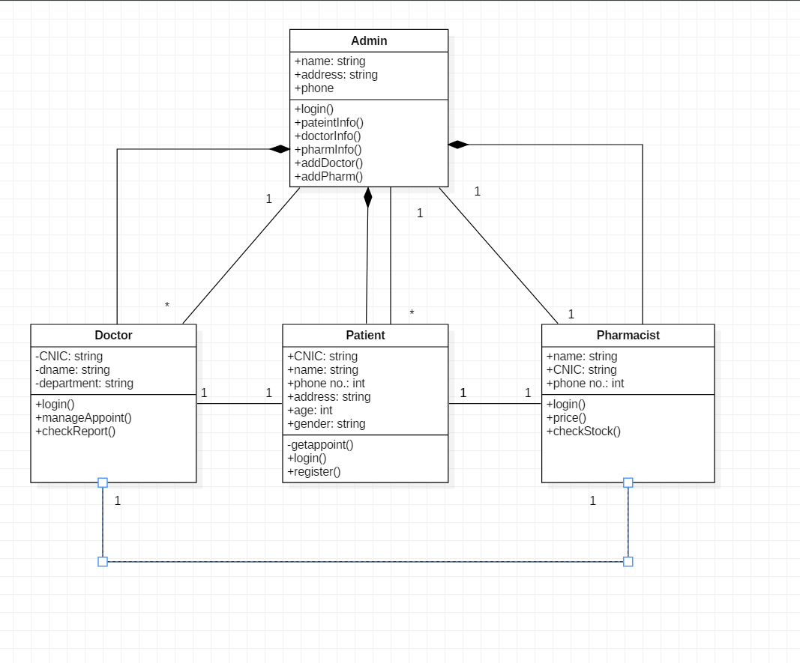

1. **Draw the sequence diagram of three major scenarios of your project.**

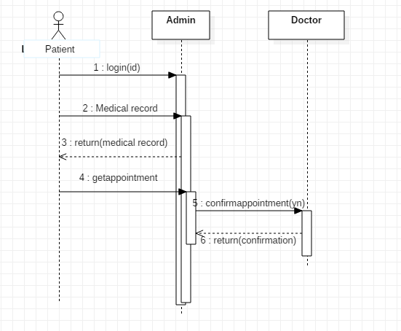

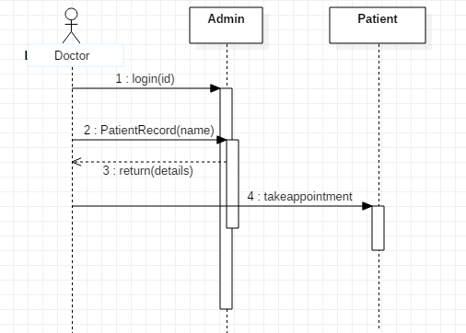

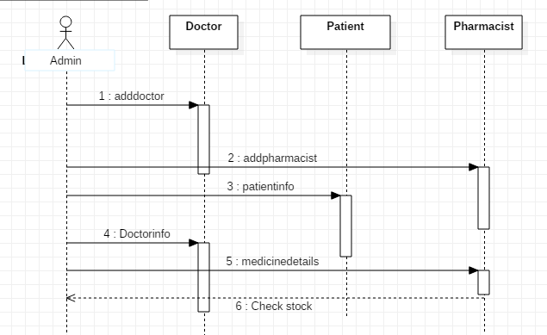

1. **Draw the ERD of your project**

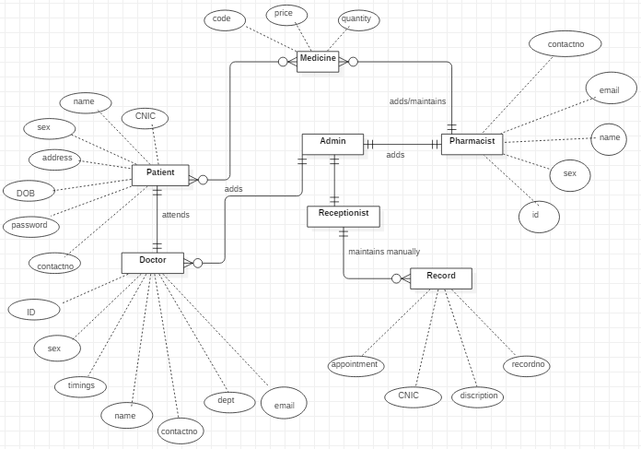

1. **Draw the DFD level 0 and level 1 of your project.**

